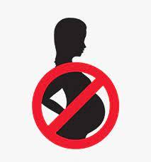

**Please make an appointment at the surgery to ensure that you have an effective method of contraception.**

**It is important that you do not stop any of your medication without discussing with a GP or a clinical pharmacist.**

**Further information about medicines in pregnancy is available on:** [**www.medicinesinpregnancy.org**](http://www.medicinesinpregnancy.org)

Teratogenic medications are medications that can potentially cause birth defects and as such should be avoided in people of childbearing potential whenever possible.

There are a variety of medications that can cause these defects and our records indicate that you are taking one of these.

**Whilst taking these medications, it is extremely important that you take effective contraception**.

Long-acting reversible contraception such as coils, implant and injections are currently recommended.

Not all contraception is suitable as sometimes the medicines you are taking may also interact with the contraceptive.



**Christchurch Medical Centre,**

**King Edward Rd,**

**Northampton,**

**NN1 5LY**

**Tel 01604 611600**

**Teratogenic Medication**